**OBE exercise for Q2 to Q9**

Day 1:

Q. 1 Survey (During session) initial session

**Day 1 home work**

1. **Describe in 100 to 150 words the methodology you follow to identify slow, moderate and**

**advanced learning diversities of your students. (Write your answer in the bullet form.)**

**(Instructions for the designer:**

1. **Put limit of maximum 150 words for this answer and provide 15 bullets to answer this question. Put maximum limit of 15 words per bullet.**
2. **After successful submission of the answer by the participant, a message will appear a follows: You have successfully submitted the response and the answer will be discussed during next session.)**

**# Answer to this question is compulsory.**

**Day 2: homework**

**3. Which student centric teaching methodology do you practice to enhance learning experience of the students? Elaborate with an example in 100-150 words. (Write your answer in the bullet form.)**

**(Instructions for the designer:**

1. **Put limit of maximum 150 words for this answer and provide bullets to answer this question and also create submit tab. .**

Submit

1. **After successful submission of the answer by the participant, a message will appear a follows: You have successfully submitted the response and the answer will be discussed during next session.)**

**# Answer to this question is compulsory.**

**Day 2: During session**

**4. Classify following sentences into:**

**a) Cognitive domain b) Affective domain and c) Psychomotor domain.**

(Given following a, b and c will be mixed while preparing questionnaire)

|  |  |  |  |  |
| --- | --- | --- | --- | --- |
| 1. | A nursing course student applies what he learned in his Psychology class when he talks to patients admitted in the hospital. | **A** | **B** | **C** |
| 2 | Students recite the English alphabets. | **A** | **B** | **C** |
| 3 | An instructor explains a theory in his own vocabulary. | **A** | **B** | **C** |
| 4 | He has learnt Formulating new patterns or structures. | **A** | **B** | **C** |
| 5 | She labels the parts of a plant. | **A** | **B** | **C** |

|  |  |  |  |  |
| --- | --- | --- | --- | --- |
| 1. | He respects sensitivity to social problems. | **A** | **B** | **C** |
| 2 | The youngster appreciates self reliance in working independently. | **A** | **B** | **C** |
| 3 | Sachin understands and accepts own strengths and weaknesses. | **A** | **B** | **C** |
| 4 | My undergraduate students cooperate one another during group activity. | **A** | **B** | **C** |
| 5 | Sanju Enjoys helping others. | **A** | **B** | **C** |

|  |  |  |  |  |
| --- | --- | --- | --- | --- |
| 1. | My friend relates this music to a particular dance movement. | **A** | **B** | **C** |
| 2 | He easily points out malfunction by sound of a machine. | **A** | **B** | **C** |
| 3 | A swimmer modifies swimming strokes to fit the roughness of the water. | **A** | **B** | **C** |
| 4 | Sanjay repairs electronic equipment quickly and accurately. | **A** | **B** | **C** |
| 5 | A cook adjusts the heat of stove to achieve the right temperature of the dish. | **A** | **B** | **C** |

**Day 2: during session**

**Q. 5. Refer to the given table and select the correct sequence based on Blooms Taxonomy.**(Note: Show tool-tip with word meaning over each word. On mouse hover)

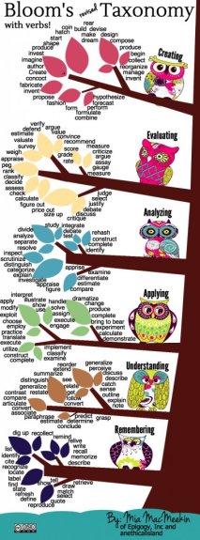

|  |  |  |  |  |  |  |
| --- | --- | --- | --- | --- | --- | --- |
|  | **Option 1** | **Option 2** | **Option 3** | **Option 4** | **Option 5** | **Option 6** |
| Level |  |  |  |  |  |  |
|  | Recognise  Debate  Explain  Experiment  Express  Analyse | Recite  Contrast  Perform  Simplify  Defend  Modify | Discuss  Demonstrate  Define  Derive  Design  Deduce | List  Summarise  Invent  Present  Classify  Develop | Indicate  Compare  Compile  Contrast  Calculate  Clarify | Read  Distinguish  Construct  Interpret  Dissect  Formulate |
|  |
|  |
|  |
|  |
|  |

|  |  |  |  |  |  |
| --- | --- | --- | --- | --- | --- |
| **Option 1** | **Option 2** | **Option 3** | **Option 4** | **Option 5** | **Option 6** |

Answer key to question 5: Option 2

(Create six tabs from option 1 to option 6 at times; the correct answer will give green blink and correct tick mark and wrong answer will give red blink and wrong message. Allow only two chances to respondent.)

**Day 2: during session**

**6) Pick the word and insert it into right level based on Blooms Taxonomy.**

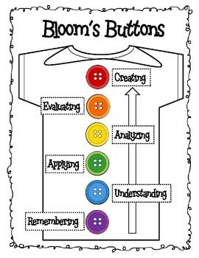

|  |  |
| --- | --- |
| Choose, Describe, Define, Label, List,Classify, Translate, Explain, Express, Review,Apply, Illustrate, Choose, Solve, Calculate, Distinguish, Differentiate, Investigate, Categorise, Compose, Assemble, Organise,Collect,Construct,Assess, Compare, Estimate, Summarize, Appraise, Restate,Discuss, Clarify,Locate,Recognise,Classify,Translate, Explain,Express,Review, Interpret, Select, Summarise, Contrast, Predict,Associate, Estimate, Extend. | |
|  | |  |
|  |
|  |
|  |
|  |
|  |
|  |

**Instruction to designer: Allow the participant to try one time for every word, if answer is wrong, the correct answer will be automatically displayed.**

**Day 2: during session**

1. **Choosing words for the sentence in a cognitive level** (Note: Fill sentence with correct answer after selection)

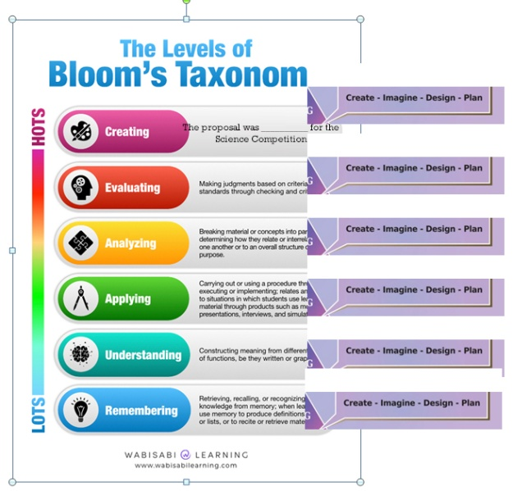

|  |  |  |  |
| --- | --- | --- | --- |
| **Level No.** | **Cognitive Level** | **Sentence** | **Words** |
| 1 | Remembering | Sunil ________ the noun clauses in the sentence. | 1. Supplies, 2. identifies, 3. justifies , 4. modifies |
| 2 | Understanding | The water- cycle is ________ in the class. | 1. Clarified, 2. demonstrated, 3. reconstructed, 4. defined |
| 3 | Applying | The knowledge of infection is _____ in the ward environment. | 1. Explained, 2. created, 3. debated, 4. demonstrated |
| 4 | Analysing | The mental health association _______ the no detention policy of the young learners. | 1. Gave reason for, 2. justified, 3. listed, 4. defended |
| 5 | Evaluating | The pollution of Mumbai was _____ by the Meteorological Department | 1. Matched, 2. appraised, 3. calculated, 4. contrasted |
| 6 | Creating | The proposal was __________ for the Science Competition | 1. Originated, 2. inspected, 3. utilized, 4. translated |

**Day 2: during session**

**8) Correlate the given sentences and decide its levels with respect to blooms taxonomy.**

|  |  |  |
| --- | --- | --- |
| **Sentences** | **Levels** | **Answer key (This is answer key, Column not to be included in question.)** |
| 1. **Determine** whether solar energy is economical |  | Evaluating |
| 1. **Differentiate** the social causes from political causes |  | Understanding |
| 1. **Appreciate** of the central idea of the poem |  | Evaluating |
| 1. **Identify** the parts of the vertebrae |  | Remembering |
| 1. **Generate** the different sea routes on a 3D model |  | Creating |
| 1. **Review** the contribution of the Indian mathematics |  | Analyzing |
| 1. **Dramatise** the role of Julius Caesar Act 2 Scene 2 |  | Applying |
| 1. **Describe** Newton’s three laws of motion |  | Understanding |
| 1. **Calculate** the kinetic energy of a football |  | Applying |
| 1. **Correlate** attendance to student performance |  | Analyzing |
| 1. **Recommend** theory of motivation |  | Evaluating |

|  |  |  |  |  |  |  |
| --- | --- | --- | --- | --- | --- | --- |
| 1 | Remembering | 2. Understanding | 3. Applying | 4. Analysing | 5. Evaluating | 6. Creating |

**(For correct answer add green correct tick mark and for wrong answer add Red Cross sign)**

**Correct answer: msg can be poped up as ‘its me/ I am here..’**

**Day 2: during session**

**9) Insert correct verbs in the boxes using Blooms revised Taxonomy.**

**Recite (#), Explain (@), Carry out ($), Identify (%), develop (*), modify(<), critique (@@), design(## ), recognize($$), recall( ^^ ), investigate (** ), create(&& ), separate( (( ), discover(+), use ( = ), show( // ), deconstruct (++ ), generate (%%), produce (00), check (!!), understand ( ??), apply(>> ), demonstrate (*****) Decide (%%%)**

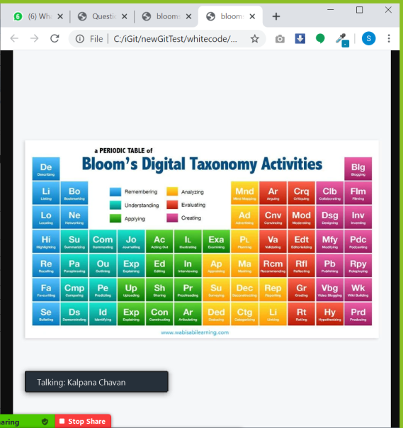

|  |  |  |  |  |  |
| --- | --- | --- | --- | --- | --- |
| **Cognitive Level** |  | **Factual** | **Conceptual** | **Procedural** | **Metacognitive** |
| Remembering | **A,b,c,d,e,f** | **#** | **$$** | **^^** | **%** |
| Understanding |  | **@** | **//** | **\*\*\*\*\*** | **??** |
| Applying |  | **>>** | **##** | **$** | **=** |
| Analysing |  | **++** | **\*\*** | **+** | **((** |
| Evaluating |  | **@@** | **<** | **!!** | **%%%** |
| Creating |  | **00** | **%%** | **\*** | **&&** |

Note: 1.Recite, Design, Recall & Identify